1.Daily notes

**Static method**

Class name.method name()

// Static method is being called using class name

// Static variable is accessed with the class name

Static method can’t access instance variable and instance method directly

**Instance method**

Obj.method name()

// Instance method is being called using object of the class

//Instance variables can be accessed inside a static method by creating an object of the class

Instance method can access Static variable and Static method directly// by creating obj to class

static int (static variable, primitive)

static Integer c=(Non Primitive)

int a = (instance variable,primitive)

2.Interview questions

3. (a)Write a class with name **Person**, inside the class write a static method **personDetails** with name,place and age. Write another static method **addressDetails** and it should include all the personal details information and also include pin code and house name. Only addressDetails should be present in main method.

call a static method inside another static method

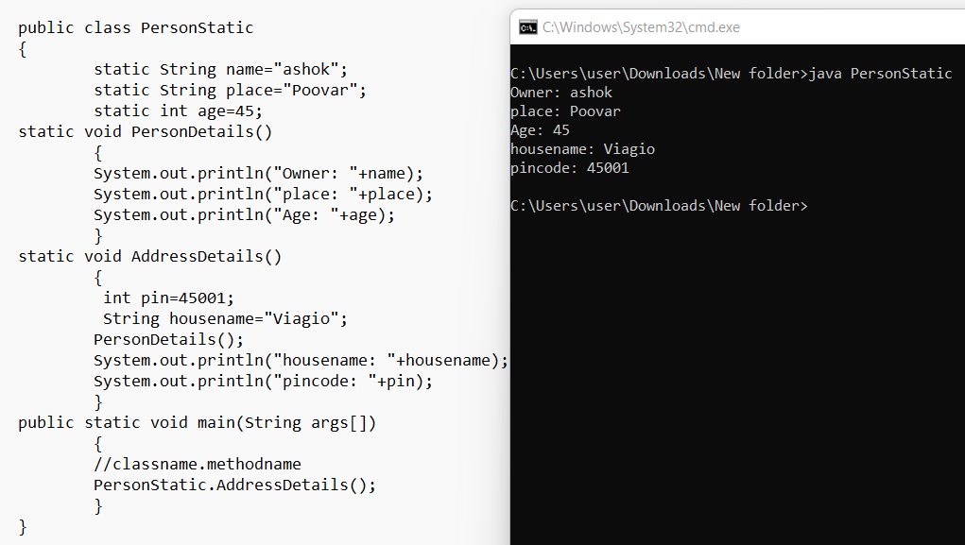

(b) Write a class with name **Person**, inside the class write a instance method **personDetails** with name,place and age. Write another instance method **addressDetails** and it should include all the personal details information and also include pin code and house name. Only addressDetails should be present in main method.

call a instance method inside another instance method

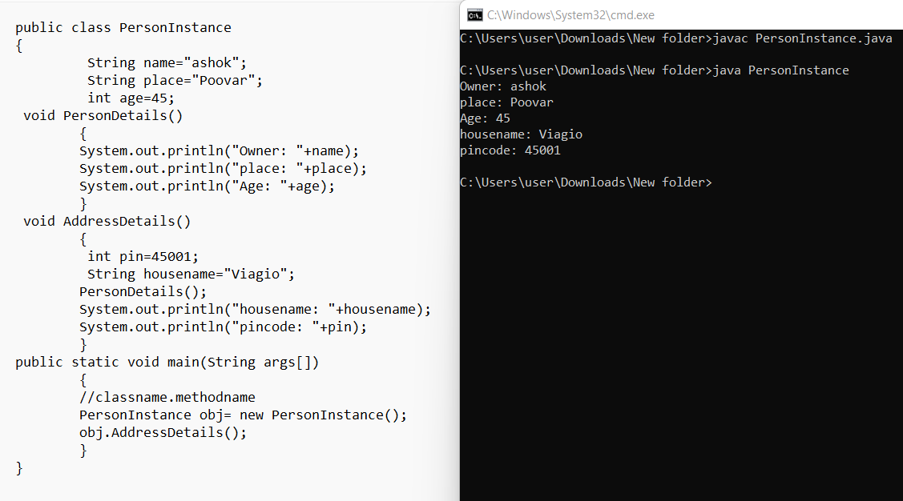

4. Write program

**Method to method**

call a static method inside another static method

call a instance method inside another instance method

call a instance method to a static method

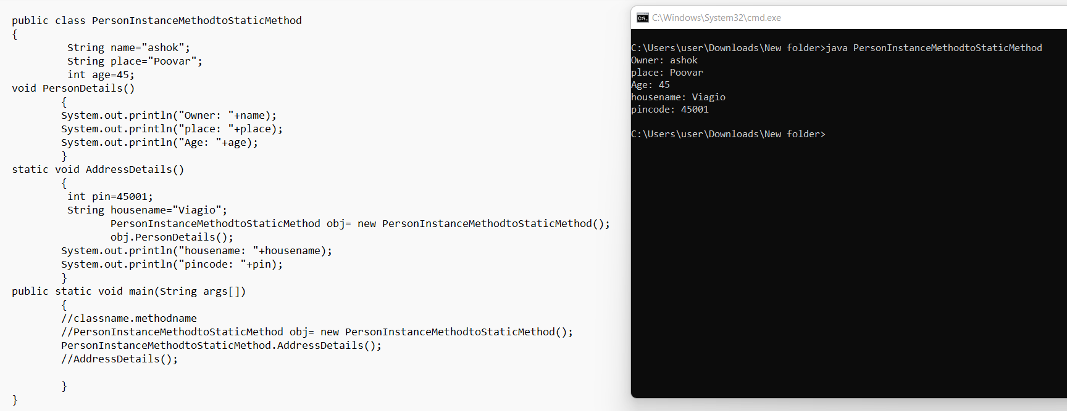

call a **static method into a instance method**

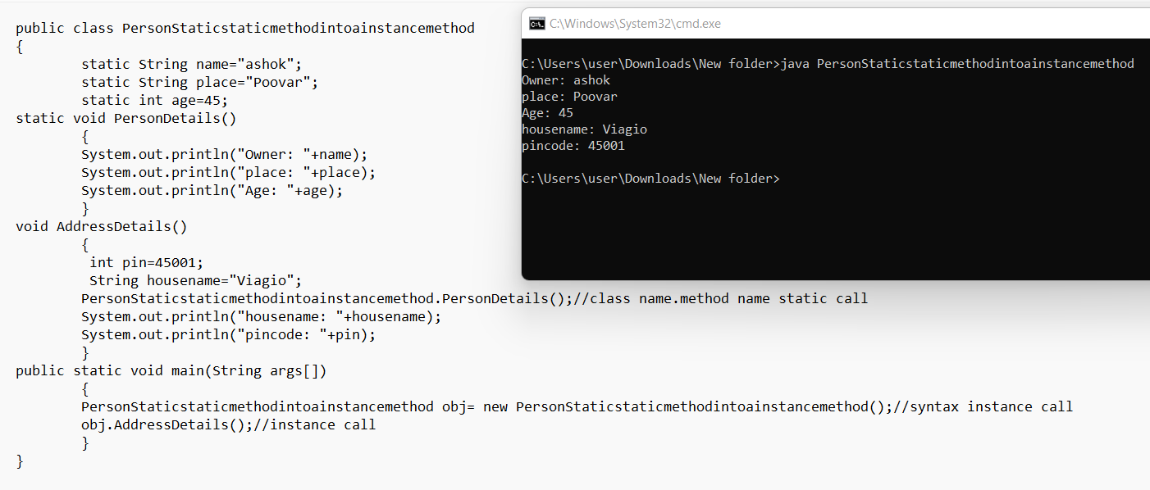

**Variable to method**

Call a static variable to a static method

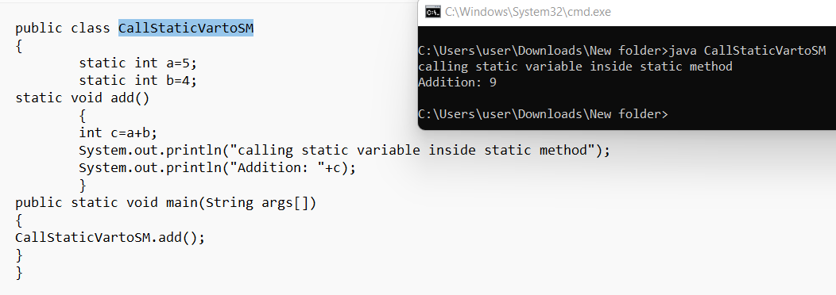

call a static variable to a instance method

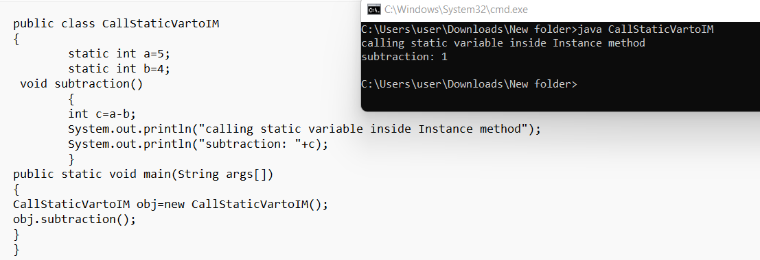

call a instance variable to a static method

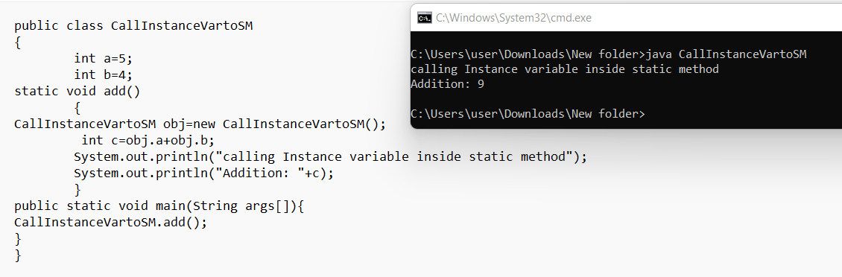

call a instance variable to a instance method

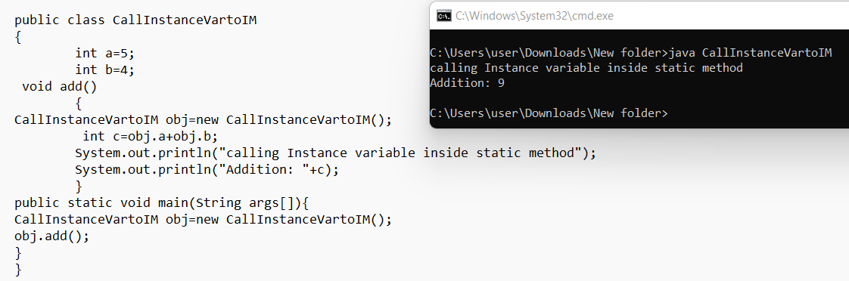

5. Difference

* Static method can’t access instance variable and instance method directly
* Instance method can access Static variable and Static method directly// by creating obj to class

Notes

Array

Array is an object, which stores a group of elements of the same data type.

It is a data structur where we can store similar elements.

Array is index based and the

first element of an array is stored in 0th index,

second element is stored on 1st index and so on.

The size of an array is fixed and hence cannot grow or shrink at runtime.

int num[]; //array declaration

num[]=new num[5]; //array instantiation

int[][]num=new int[row][col];//Multi dimentional array

Example:

int[]num={1,2,3,4,5};//

Continue statement //continue;

the continue statement is used within loop constructs (such as for, while, and do-while loops)

to skip the remaining code within the loop body and move to the next iteration.

When the continue statement is encountered,

it immediately jumps to the loop's conditional expression (for for and while loops)

without executing any of the subsequent statements in the loop's body for the current iteration

Break statement //break

It is used to prematurely terminate a loop or a switch statement.

When the break statement is encountered,

the control immediately exits the loop or the switch statement,

and the program continues with the statement following the loop or the switch.